Degrees of Freedom

The number of independent ways something can move.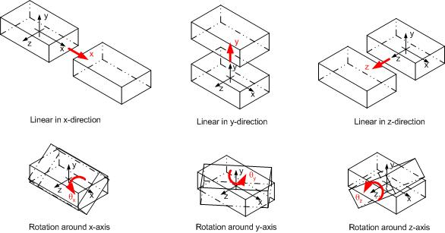

For most objects, we have three shifts…

(Front/back, side to side, and up/down)

…and 3 rotations

(yaw, pitch, roll)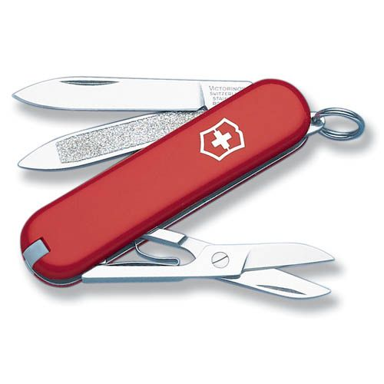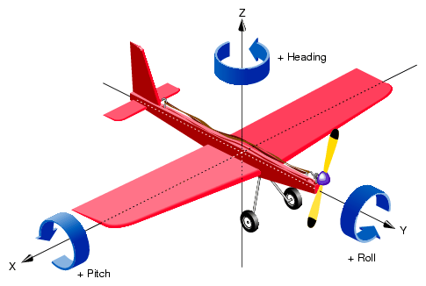

But many objects also have moving parts!

How many independent ways can this knife move?

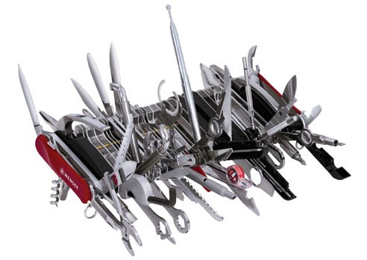

… how about this one?